FRONT-END Developing Course

Frontend refers to the part of a software application or website that users interact with directly. It includes everything users experience visually such as layout, buttons, forms, animation and navigations menus.

**TO design better we will be learn:**

**HTML**- Hyper Text Markup Language

**CSS**- Cascading Style Sheet  
**Javascript**

**H T M L**

HTML: HTML stands for **HYPER TEXT MARKUP LANGUAGE.**

* By using HTML, we can create our own website.
* HTML is the standard markup language for creating web pages
* HTML describes the structure of web page.
* HTML elements tell the browser how to display the content.

<!Doctype>

<HTML>

<HEAD>

<TITLE> 

<BODY>

<a> - anchor tag used for create link. To make link clickage attribute is used.

<a href= “link or path”,

<a href="https://careers.wipro.com/" target="_blank"> Wipro Career </a>

**FORM**

An HTML form is used to collect user input. Which is most often sent to a server for processing.

<form action="" method="post" enctype="multipart/form-data">

Method:

Action=“” (Backend use to call url)

Enctype=”” (using to transfer multiple types of data)

 <label for="name"> Enter Your Name: </label>



<input type="text" placeholder="Enter Name" name="name">

Input type: box for write anything. (Enter Name)

Placeholder: text into box



<label for="name"> Enter Your Name: </label>

            <input type="text" placeholder="Enter Name" name="name">

            <br> <br>



<select name="city">



<label for="city"> Enter City: </label>

            <select name="city">

                    <option value="">--select city--</option>

                    <option value="Ahemdabad"> Ahemdabad </option>

                    <option value="Vadodara"> Vadodara </option>

                    <option value="surat"> Surat </option>

            </select>

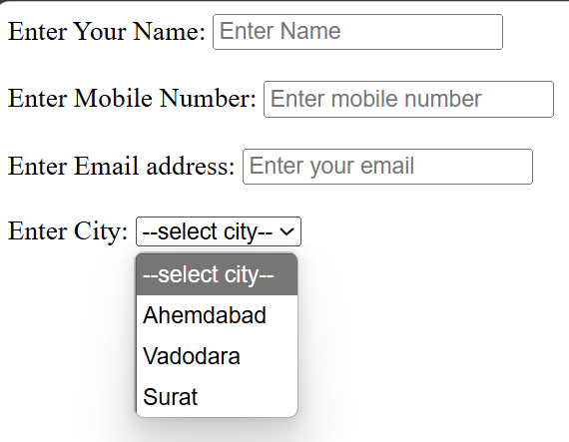

**Date and Time:**

<label for=""> Date: </label>

            <input type="date">

       <label for=""> Time: </label>

            <input type="time">

            <br>

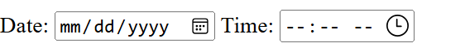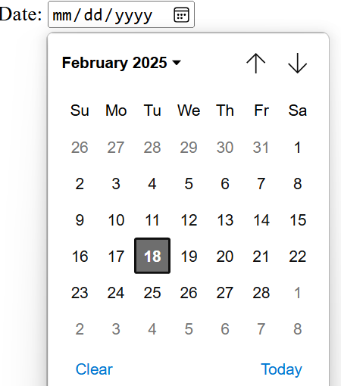 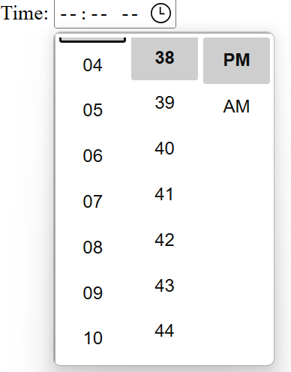

**Radio Button:**

<label for=""> Gender </label>

            <input type="radio" value="Male" name="gender"> Male

            <input type="radio" value="Female" name="gender"> Female

**Radio:** to choose any one

**Name=”gender”** (it will be help to select only one)

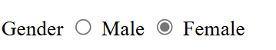

**Checkbox:**

<label for=""> Sports </label>

            <input type="checkbox" value="Cricket" name="Cricket"> Cricket

            <input type="checkbox" value="Football" name="Football"> Football

            <input type="checkbox" value="Chess" name="Chess"> Chess

